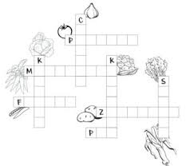
KRZYŻÓWKA

