**ROZWIĄŻ REBUSY – JAKIE TO ZAWODY**



**NICA = CA**

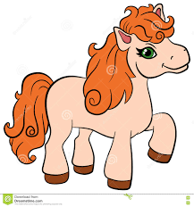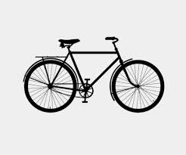

**WER = L + ~~KO~~**



**NKA = ARZ**





**~~ORKIE~~  + BA=K**